**MINDFULNESS MEDITATION WORKSHOP WITH LYNDI SMITH**

**Nature inside and Outside**

**What we call mindfulness is a practice of *listening deeply*.**

*The dew glistening on the tip of a curving leaf. The gentle rushing of the ocean waves. The smell of jasmine, after the rain. The feel of the soft, shredded trunk of the paperbark tree.*

By listening deeply, both to the nature outside us, and the nature inside us, we uncover a wealth of calm, care, clarity and connection.

This awareness is innate to human beings, and by looking, listening and learning from our experience, awareness develops into wisdom and compassion.  Indigenous cultures and insight traditions have been practising this for many thousands of years.

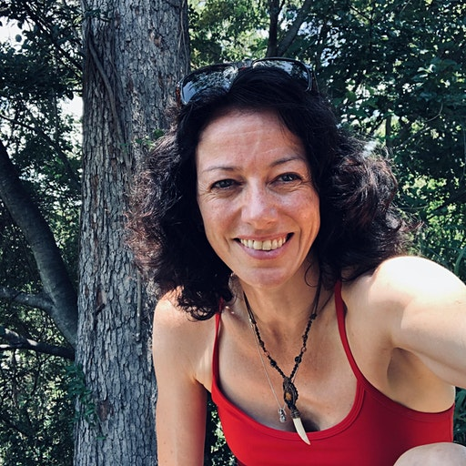

We have a wonderful opportunity to come together for a weekend to practise this!

Together we’ll explore:

—mindfulness meditation and nature connection

—awareness of the body, senses, thoughts, feelings and emotions

—cultivating calm and insight

—moving meditation and mindful walking

—open awareness, a way of meditating that can feel very natural

—cultivating love, joy, compassion and equanimity

Lyndi Smith is a nature lover and meditation teacher within the insight tradition. Her main practice is “listening deeply”- listening to the nature outside of us, and the nature inside. This practice is akin to “open awareness”. Having trained in both secular and traditional mindfulness, she is qualified to teach many forms of meditation (BSY), including nature connection, qi gong and self-compassion (MSG). Her main teachers have come from Burmese and Tibetan traditions.

She teaches mindfulness and compassion full time, in organisations, schools, healthcare and adult classes and regularly instructs at Heart Insight in Brisbane.

She loves learning about indigenous culture in this land called Australia and pays respect to elders past, present and future, as well as her mentors and brothers sisters within the Tibetan, Aboriginal and Celtic tradition. She is delighted to be invited to Rockhampton for this retreat on traditional Darumbal land.

**This workshop is for both new and experienced meditators**

**When: Sat 5 June 2021 & Sun 6 June 2021 9 am – 5 pm both days**

**Women’s Health Centre, 225 Bolsover St, Rockhampton (entrance opposite VibeFitness)**

**$100 ($80 concession) Payment is by cash on the first morning**

**Lunch, Tea/coffee provided**

**This covers basic pay for the teacher. Further donations or dana to Lyndi are very welcome**

**To book please contact Sama 0478 630 888 or Irena 0417 259 669**

**Or Email:** [**bmsmetta@gmail.com**](mailto:bmsmetta@gmail.com) **with your contact details by Thursday 3 June**

**There are chairs provided at centre, but please BYO cushion & a folding chair/mat for outside meditation**

**Please book early as places are limited due to Covid**