LOVING NATURE: THE HEART OF MEDITATION
A RESIDENTIAL WEEKEND RETREAT WITH PASHA LYNDI
🌿 Earth-based meditations on Love, Joy, Compassion and Balance 🌿
Falling in love with the sound of the ocean waves. Surrendering our cares, and being held by the good earth. How the soft touch of the paperbark opens our heart. Letting the compassion of the water soothe our pain. Remembering the kindness and care of our elders and loved ones.
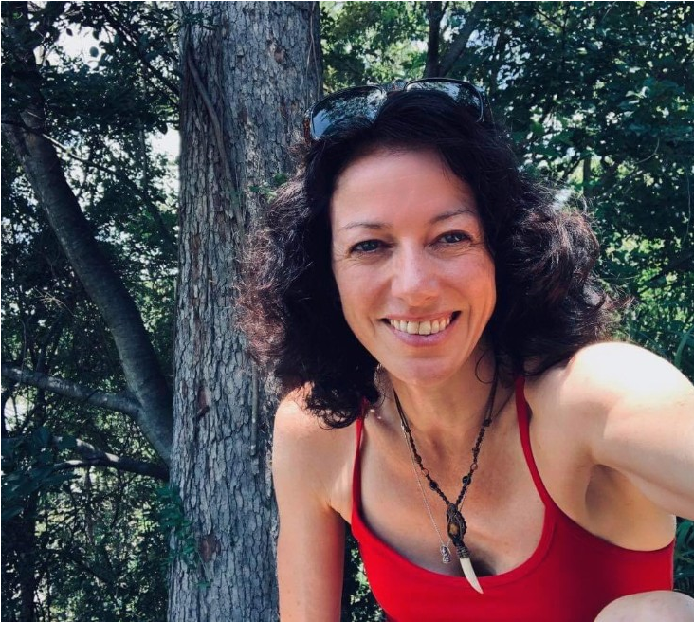
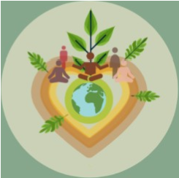
When we connect lovingly to the nature outside us, and the nature inside us, we feel well and happy, safe and supported.

Care is innate to human beings, and by remembering our connection to earth and community, we develop both insight and limitless love, joy, compassion and balance. Indigenous cultures and insight traditions have been practising this for thousands of years.
What a wonderful opportunity to come together for a weekend retreat to practise this!
Together we’ll explore:
—earth-based ways to love our nature
—cultivating love, joy, compassion and equanimity
—awareness of the body, senses, thoughts, feelings and emotions
—moving meditation and mindful walking
—listening deeply, nature connection
We will follow a traditional retreat format, with periods of stillness and moving meditation. There will be some time for connection and sharing, and some time spent in friendly silence.
Pasha Lyndi is a nature lover and meditation teacher within the insight tradition. Her main practice is “listening deeply,” listening to the nature outside of us and the nature inside, akin to ‘open awareness’.
Having trained in both secular and traditional mindfulness, she is qualified to teach many forms of meditation (BSY), including nature connection, qi gong and self-compassion (MSC). She teaches mindfulness and compassion full time, in organisations, schools, healthcare and adult classes and regularly instructs at Heart Insight in Brisbane. Her main teachers have come from Tibetan, Burmese, Aboriginal and Celtic traditions.
She loves learning about indigenous culture in this land called Australia and pays respect to elders past, present and future, as well as her Irish ancestors and mentors, brothers and sisters within other traditions. She is delighted to be invited back to Rockhampton for this retreat on traditional Darumbal land.
This retreat is for both new and experienced meditators
When: 5 pm Fri 2 September – 4 pm Sun 4 September 2022
Where: Discovery Parks Yeppoon 760 Scenic Highway Kinka Beach QLD
Fee payable on the day: $200.00 includes accommodation & all meals. This covers basic pay for teacher. Donations to Pasha are very welcome
For bookings: please contact rockhamptoninsightmeditation@gmail.com or 0478630888

