**HEALING THE HEART-MIND WITH MINDFULNESS**

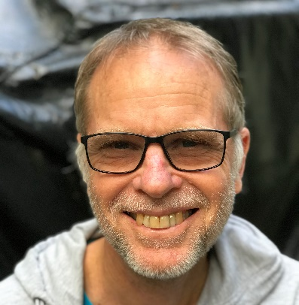**BY MAL HUXTER**

**Talk on Friday evening Oct 6, 2023 7 pm-8 pm**

In this talk Malcolm will refer one of the chapters of a book he has written: Healing the heart and mind with mindfulness

The talk will involve discussion about the integration of contemporary clinical

psychology with ancient Buddhist teachings and practices in order to overcome anxiety,

depression and stress and find psychological freedom and well-being. Malcolm will

discuss some of the causes and conditions of these forms of human suffering and

highlight how we can short circuit destructive reactive patterns and cultivate that which

is freeing.

This Friday evening will include a brief guided meditation as well as time for questions.

**Malcolm Huxter** is a clinical psychologist and teacher of Buddhist meditation. He has

been teaching mindfulness and related practices such as loving kindness and

compassion to clinical populations, clinicians and the general public for over 30 years.

Mal originally learnt these practices as a Buddhist monk in Thailand in the late 1970’s.

Mal has written several mindfulness-based workbooks, published in psychology journals

and magazines and had a book called “Healing the heart and mind with mindfulness.

Ancient path, present moment” released in 2016. He works in private practice and

regularly teaches on courses, workshops and retreats. Malcolm likes to teach a

balance of insight, serenity and the four divine abode meditations. He utilises

traditional Buddhist wisdom as well as the insights and knowledge of contemporary

neuro-science and psychology to teach an integrated approach to healing and

awakening.

**AT**: ANANDA BUDDHIST CENTRE CORNER HINCHCLIFF & MUNRO ST KAWANA ROCKHAMPTON

**WHEN:** FRI 6 OCT 7 PM – 8 PM Tea/Coffee Refreshments after

**FEE:** BY DONATION

**TO REGISTER:** PLEASE EMAIL [rockhamptoninsightmeditation@gmail.com](mailto:rockhamptoninsightmeditation@gmail.com) or contact 0478630888