Rockhampton Regional Council
Bolsover Street (Cnr Derby St)
Rockhampton, QLD 4700

ROCKHAMPTON REGIONAL COUNCIL

SALE BY QUOTE

for

Pig

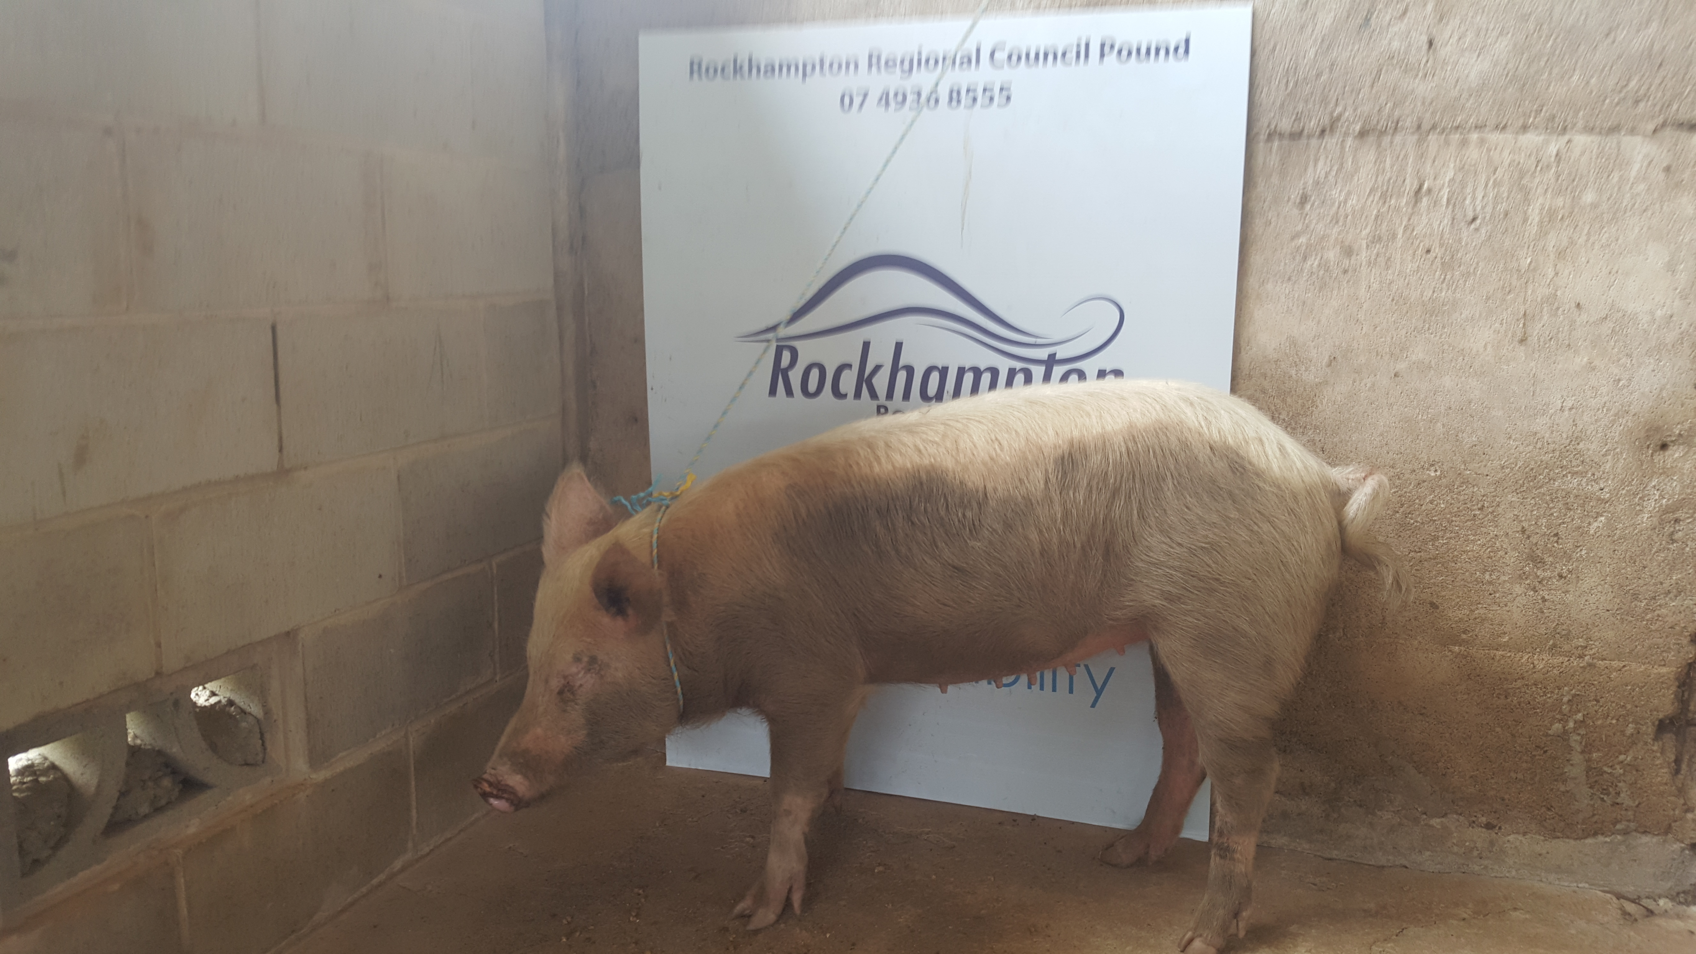

QUOTE NUMBER : QUO0001

QUOTE CLOSING TIME AND DATE: 2:00 PM Monday 07/11/2016

OFFERS MUST BE RECEIVED NO LATER THAN THIS TIME AND DATE.

LATE SUBMISSION WILL ONLY BE ACCEPTED AT THE SOLE DISCRETION OF COUNCIL

CONDITIONS OF QUOTE

The details of the Quote closing date and time are on the cover page of this Invitation to Quote

Queries by Offerer

Queries in relation to this quotation should be directed to:-

The Rockhampton Pound
Rockhampton Regional Council
Ph: 07 4936 8555

Quotes

Lodgement of Quote

Offerers are to submit their Offer in the manner required by this clause 2.1 on or before the Quote Closing Time that is set out on the cover page of this Invitation to Quote.

Submissions marked to the attention of The Rockhampton Pound may be lodged in one of the following formats:
- Sent by mail to PO Box 1860, Rockhampton, Qld, 4700; or
- Hand delivered at 232 Bolsover Street, Rockhampton, 4700; or
- Emailed to enquires@rrc.qld.gov.au

Validity of Quote

Offerers must keep their Offer open for acceptance for sixty (60) days from the Quote Closing Time. Should Council not accept an Offer within this period, the Offerer may withdraw their Offer.

Opening of Offers

There will not be a public opening of the Offers received

Acceptance and consideration of Offers

Council is under no obligation to accept any offer.

DESCRIPTION OF Goods

1 x Female Pig

CONDITIONS OF CONTRACT

Purchase

Council is seeking offers for the sale of 1 x female pig as described in Clause 3 – Description of Goods.

The Goods will be sold in an ‘as is’ condition.

Council makes no guarantee to the condition of the goods.

Removal

The offerer shall remove the goods at their own cost.

Payment

Payment is to be made in full prior to the removal of the goods.

Must have an allotment with an area of 4,000m² or more.
4.3.3 That any enclosure in which the animal is kept is not located within a radius of 10m of—
(a) a residence on adjoining premises; or
(b) a place used for the manufacture, preparation or storage of food intended for human consumption other than a domestic kitchen used solely for domestic purposes by the owner or responsible person for the animal; or
(c) a place used for the storage of food (other than food kept in hermetically sealed packages).

Insurance

Offerers shall be appropriately insured to remove the goods from the site.

Rockhampton Regional Council shall not be held liable for any injuries or damage to personnel, property or plant resulting from the successful Offerer collecting and removing the goods from the site.

Quote form

Details of Offerer | Name of Offerer  ............................................................................................................................
Details of Offerer | Street Address of Offerer  .........................................................................................................................................  .........................................................................................................................................
Details of Offerer | Postal Address of Offerer  .........................................................................................................................................  .........................................................................................................................................
Details of Offerer | Telephone No. | Facsimile No. | Email
A.C.N/ A.B.N:
Purchase Price | $........................................................................(plus applicable GST)
Details of Person Signing Form | Name of Person Signing Quote Form  .............................................................................................................................
Details of Person Signing Form | Position Held or Details of Authority to Sign Quote Form (if Corporation)  .............................................................................................................................  .............................................................................................................................
Signature |  |  |  | Date
Witness Name
Witness Signature |  |  |  | Date

