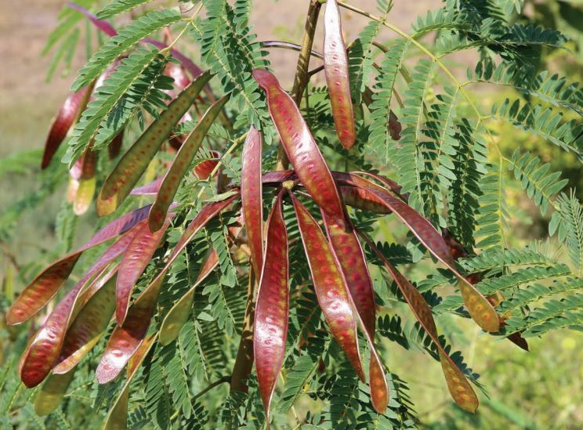

**Rockhampton Regional Council**

**Pest Management Unit**

**P.** 07 4932 9000 | **E.** [enquiries@rrc.qld.gov.au](mailto:enquiries@rrc.qld.gov.au) | **W.** [www.rrc.qld.gov.au](http://www.rrc.qld.gov.au/)

Council is here to help you weed out pest plants on your property

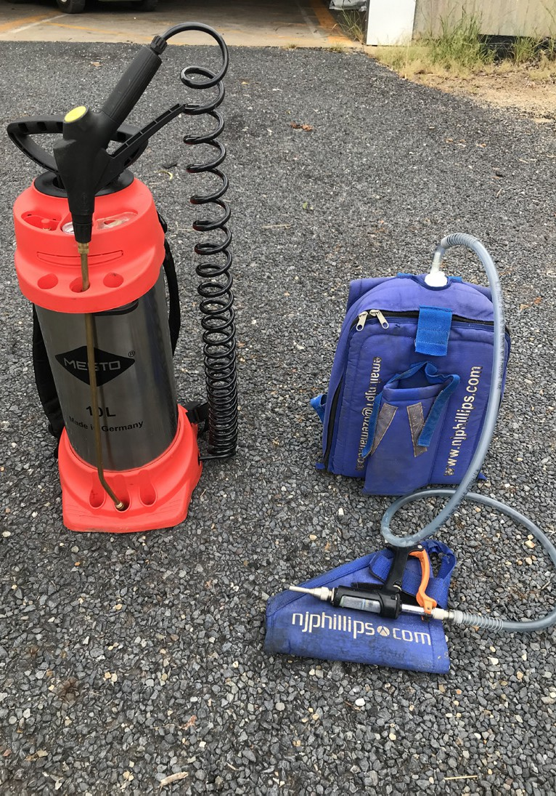 **Diesel Knapsacks**

Rockhampton Regional Council has Diesel Knapsacks available for hire by residents who are trying to tackle hard to kill pest plants on their property.

Diesel Knapsack hire options are;

* Dry Hire
* Prefilled with 5 Litres of diesel and herbicide
* Prefilled with 10 Litres of diesel and herbicide

To utilise this service, visit our website at [www.rrc.qld.gov.au,](http://www.rrc.qld.gov.au,) complete the relevant Request Form and submit it to a Council Customer Service Centre in Rockhampton, Gracemere or Mount Morgan.

The hire of these units have a hire per week cost plus safety deposit, with all fees and charges being found on Council’s website.