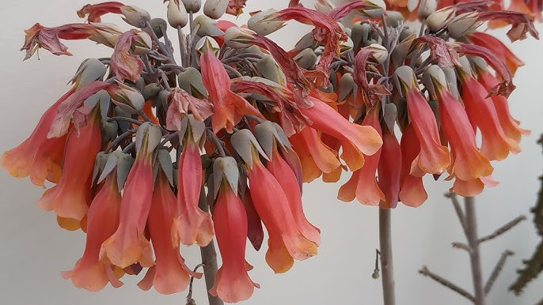

**Rockhampton Regional Council**

**Pest Management Unit**

**P.** 07 4932 9000 | **E.** [enquiries@rrc.qld.gov.au](mailto:enquiries@rrc.qld.gov.au) | **W.** [www.rrc.qld.gov.au](http://www.rrc.qld.gov.au/)

Council is here to help you weed out pest plants on your property

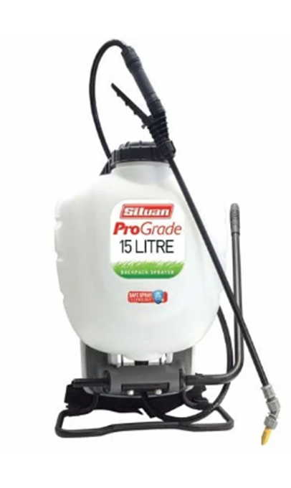 **Knapsacks**

Rockhampton Regional Council has Knapsacks with water-based chemical (24D or similar) available for hire by residents who are trying to control small scale pest plants on their property. A knapsack sprayer disperses liquid through a hand-held nozzle that is attached to a pressurized reservoir carried on the operators back and is suited to spot treating areas.

The hire of these units have a hire per week cost plus safety deposit, with all fees and charges being found on Council’s website.

To utilise this service, visit our website at [www.rrc.qld.gov.au,](http://www.rrc.qld.gov.au,) complete the relevant Request Form and submit it to a Council Customer Service Centre in Rockhampton, Gracemere or Mount Morgan.