**Splatter Guns**

Splatter guns are designed to shoot a low volume, high concentrated stream of herbicide at a target plant up to 10 meters away. Because of the high concentration you only need to partially cover the leaves and stem; do not cover the entire plant. This technique is particularly useful in areas of difficult access or sensitive vegetation, because the tool is easily portable and causes limited off target damage. The amount of herbicide needed is reduced resulting in lower cost to the user.

Furthermore, splatter guns are easy to use on horseback, motorcycle or all-terrain vehicles and are especially ideal for controlling Lantana.

**Conditions and Procedures**

1. Bookings in relation to the hire of Council’s splatter guns are to be made through Customer Service on 07 4932 9000.
2. A minimum of two business days’ notice prior to collecting the splatter gun is required.
3. The deposit and hire fees must be paid to Customer Service either at Rockhampton, Gracemere, Mount Morgan, or over the phone prior to hire. A receipt will then be issued.
4. The splatter gun is to be collected from Council’s Rural Operations Depot, 56 Saleyards Road, Gracemere before 2pm Monday – Friday. Splatter guns must be returned before 10am on the nominated return date (splatter guns cannot be collected or returned over a weekend or public holiday).
5. Hire charges for the splatter gun will apply irrespective of whether the hirer has used the equipment during the hire period (weather permitting).
6. Splatter guns are hired out on a weekly basis only. Items can be returned early, however a refund of hire fees will not be provided.
7. Council is not liable for any damage to any person or property, animal, crop, water supply etc. while the equipment is in the control of the hirer.
8. Protective equipment such as gloves, overalls, respirators and goggles, as described on the product label, should be used when mixing and spraying chemicals. This equipment will not be provided by Council.
9. To ensure a full refund of the deposit is received, hirers must comply with the following conditions:

* The hirer is responsible for any damage which occurs to the splatter gun whilst in their possession. The cost of repairs will be taken from the deposit and the remaining deposit refunded. If the cost of the repairs is more than the deposit, an invoice for the difference will be issued to the hirer. Upon return of the equipment, an officer will inspect the item for damage to ascertain whether damage has occurred during the hire period.
* Additional hire fees will apply if the splatter gun is returned later than 24 hours after the hire period has finished.
* The splatter gun tank is to be emptied and flushed before returning to Council.
* 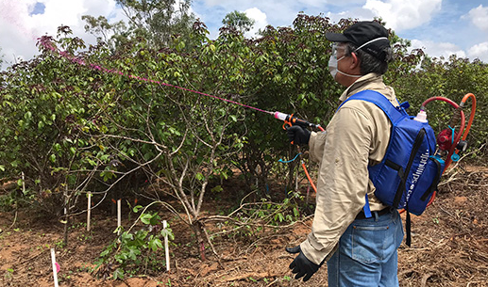If the equipment is in good working order, the deposit will be refunded in full via Council electronic funds transfer as soon as practicable (if requested, frequent users may request Council to hold the deposit for future hires).