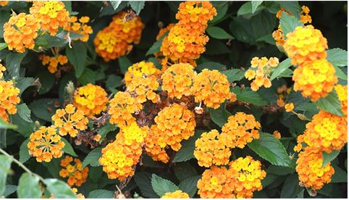

**Rockhampton Regional Council**

**Pest Management Unit**

**P.** 07 4932 9000 | **E.** [enquiries@rrc.qld.gov.au](mailto:enquiries@rrc.qld.gov.au) | **W.** [www.rrc.qld.gov.au](http://www.rrc.qld.gov.au/)

Council is here to help you weed out pest plants on your property

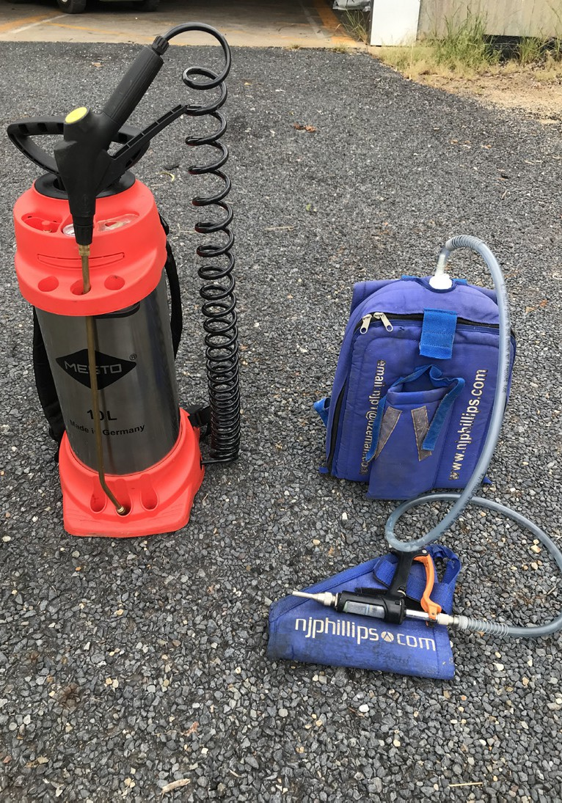 **Splatter Guns**

Rockhampton Regional Council has Splatter Guns available for hire by residents who are trying to tackle pest plants on their property. This method involves applying a low volume of a concentrated herbicide mix to foliage. This technique is particularly useful for areas that are difficult to access. The splatter gun spraying method is typically used to control infestations of Lantana.

The hire of these units have a hire per week cost plus safety deposit, with all fees and charges being found on Council’s website.

To utilise this service, visit our website at [www.rrc.qld.gov.au,](http://www.rrc.qld.gov.au/) complete the relevant Request Form and submit it to a Council Customer Service Centre in Rockhampton, Gracemere or Mount Morgan.