**Weekend Meditation Retreat with Bhante Akāliko**

# **Love and Hate – on Sat**

The Buddha encouraged us to develop a mind of love for all beings but sometimes our capacity for love is hidden by hurt, resentment and hatred. In this one day workshop, learn how you can heal your hate and transform your mind, filling your heart with boundless love for all living beings.

**Life and Death – on Sun**

The Buddha taught mindfulness of death to create a sense of urgency in our spiritual practice and develop wisdom into the impermanent nature of our existence. Reflecting on the reality of death prepares us for the inevitable but more importantly, helps us understand the very meaning of life.  
  
Join Bhante Akāliko for this weekend retreat and learn how to transform your practice into a powerful tool to cut through ignorance and illuminate your mind with wisdom.

*This workshop is suitable for both new and experienced meditators.*

**About the Teacher**

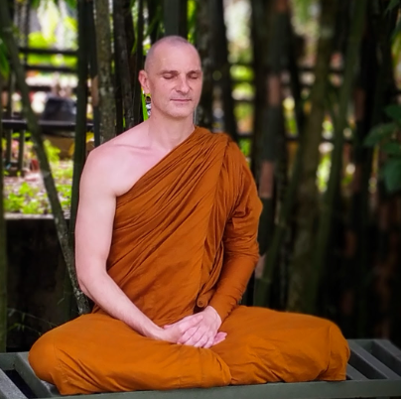

Akāliko Bhikkhu is an Australian monk in the Theravada forest tradition. He is the spiritual director of Little Dust and founder of Rainbodhi LGBTQIA+ Buddhist Community. Bhante Akāliko is also the spiritual advisor of Central West Buddhists and a chaplain at Western Sydney University. He sits on the boards of the Buddhist Council of NSW and the Federation of Australian Buddhist Councils.

Bhante Akāliko went forth as a monastic in 2016 and received full ordination with Ajahn Brahm at Bodhinyana monastery in 2017. He later stayed for several years with Bhante Sujato at the Monastery at the End of the World in Sydney and now lives as a wandering monk.

**Dates: Sat 16th March & Sun 17 March 9 am – 5 pm both days**

**Location**: Ananda Buddhist Centre corner Alexandra St & Munro St Kawana Rockhampton Qld 4701

**Information**: Sama 0478 630 888 VJ 0475 758 022

[rockhamptoninsightmeditation@gmail.com](mailto:rockhamptoninsightmeditation@gmail.com)

**Fee**: $ 100 This includes vegetarian lunch morning & afternoon tea. This is to cover the costs of the workshop.

*The teachings are given free. Dana (or donations to teacher) are very welcome. Teachers rely on donations as their sole income*